EXP 20

AIM: Design TM using simulator to perform subtraction of aaa-aa

INPUT:

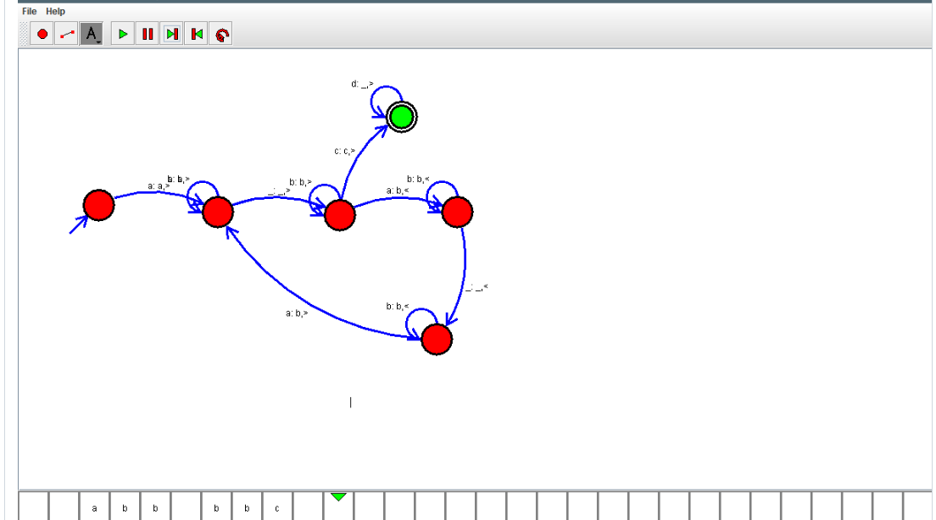

OUTPUT:



RESULT: Design TM using simulator to perform subtraction of aaa-aa is successfully verified